# 

## REHEMA SCHOOL PREFECTS ELECTROL SYSTEM

NAME: JOSHUA MWAMLANDA BARAWA

INDEX NUMBER: O3108101117

SCHOOL: MOI FORCES ACADEMY MOMBASA

YEAR: 2019

DURATION: 7MONTHS

Table of Contents

REHEMA SCHOOL PREFECTS ELECTROL SYSTEM 1

1

ACKNOWLEDGEMENT 7

DEDICATION 8

CHAPTER ONE: INTRODUCTION 9

1: PROBLEM RECOGNITION 9

CHAPTER TWO: SYSTEM ANALYSIST 9

2.1: PROBLEM DEFINITION 9

2.2: FACT FINDING 9

2.3: OVERVEIW OF THE EXISTING SYSTEM 9

STUDENT ADMINISTRATION STRUCTURE 10

2.4: OVERVIEW OF THE PROPOSED SYSTEM 10

OBJECTIVES OF THE PROPOSED SYSTEM 10

SCOPE OF THE NEW SYSTEM 10

FEASIBILITY STUDY 11

CHAPTER THREE: SYSTEM DESIGN 12

3.1: SYSTEM FLOWCHART 12

3.2: TABLE AND FILE STRUCTURES 13

CLASS AND CLASS TEACHERS TABLE 13

CONTESTANTS TABLE 13

ELECTROL POSITION TABLE 13

STUDENTS TABLE 14

PROPOSERS AND SECONDERS TABLE 14

RESULTS TABLE 14

3.3: INPUTS SCREENS 15

CLASS AND CLASS TEACHER FORM 15

CONTESTANTS FORM 15

3.4: OUTPUT SCREENS 18

3.5: HARDWARE AND SOFTWARE CONSIDERATION 21

HARDWARE RESOURCES 21

SOFTWARE CONSIDERATION 21

CHAPTER FOUR: SYSTEM CONSTRACTION 22

4.1: TABLE STRUCTERS 22

CLASS AND CLASS TEACHER TABLE 22

CONTESTANT TABLE 22

ELECTROL POSITION TABLE 23

STUDENT TABLE 23

PROPOSERS AND SECONDERS 24

RESULTS TABLE 24

4.2: RELATIONSHIPS 25

4.3: INPUT SCREENS CONSTRUCTION 26

DATA ENTRY FORM CONSTRUCTION 26

CLASS AND CLASS TEACHER FORM 26

CONTESTANT AND VOTES GARNERED FORM 27

CONTESTANTS FORM 28

PROPOSER AND SECONDER FORM 29

RESULTS FORM 30

SPOILT VOTES FORM 31

STUDENTS FORM 32

VOTERS FORM 33

WINNER FORM 34

4.5: DATA MANIPILATION 35

PROPOSERS AND SECONDERS QUERY 35

SCHOOL LEVEL WINNERS QUERY 35

FORM LEVEL QUERY 36

CLASS LEVEL QUERY 36

CONTESTANTS SCHOOL LEVEL QUERY 37

CONTESTANTS FORM LEVEL QUERY 37

CONTESTANT CLASS LEVEL QUERY 38

SCHOOL LEVEL VOTES QUERY 38

4.6: OUTPUT SCREEN CONSTRUCTION 39

CONTESTANT AND VOTES GARNERED REPORT 39

STUDENTS REPORT 39

VOTERS REPORT 40

RESULTS REPORT 40

SCHOOL LEVEL WINNERS REPORT 41

FORM LEVEL WINNERS REPORT 41

CLASS LEVEL WINNERS REPORT 42

CHAPTER 5: PROGRAM REQUIREMENTS AND INTALLATION 43

5.1: Requirements 43

5.2: Installation 43

5.3: Loading the system 44

5.4: DATA ENTRY AND MANIPULATION 47

5.5: EXITING THE SYSTEM 47

5.6: ERROR MESSAGES 48

CHAPTER 6: CONCLUSION AND RECOMMENDATIONS*.* 49

6.1: CONCLUSION 49

6.2: RECOMMENDATIONS 49

6.3: BIBLIOGRAPHY 49

PROJECT APPENDIX 50

Appendix 1:CLASS AND CLASS TEACHER TABLE 50

Appendix 2: CONTESTANTS TABLE 50

Appendix 3: RESULTS TABLE 51

Appendix 4: SPOILT VOTES TABLE 51

Appendix 5: WINNER TABLE 52

Appendix 6: CONTESTANTS AND VOTES GARNERED TABLE 52

Figure 1 12

Figure 2 13

Figure 3 13

Figure 4 13

Figure 5 14

Figure 6 14

Figure 7 14

Figure 8 15

Figure 9 15

Figure 10 16

Figure 11 16

Figure 12 17

Figure 13 17

Figure 14 18

Figure 15 18

Figure 16 19

Figure 17 19

Figure 18 19

Figure 19 20

Figure 20 20

Figure 21 21

Figure 22 21

Figure 23 21

Figure 24 22

Figure 25 22

Figure 26 23

Figure 27 23

Figure 28 24

Figure 29 24

Figure 30 25

Figure 31 26

Figure 32 27

Figure 33 28

Figure 34 29

Figure 35 30

Figure 36 31

Figure 37 32

Figure 38 33

Figure 39 34

Figure 40 35

Figure 41 35

Figure 42 36

Figure 43 36

Figure 44 37

Figure 45 37

Figure 46 38

Figure 47 38

Figure 48 39

Figure 49 39

Figure 50 40

Figure 51 40

Figure 52 41

Figure 53 41

Figure 54 42

Figure 55 44

Figure 56 45

Figure 57 46

Figure 58 47

Figure 59 48

Figure 60 48

Figure 61 48

Figure 62 50

Figure 63 50

Figure 64 51

Figure 65 51

Figure 66 52

Figure 67 52

# ACKNOWLEDGEMENT

I am thankful to the following individuals for giving me appropriate support and advice during the development of my project: my parents, the school administration, my computer studies teacher, and all my fellow students who always encouraged me to keep on my hard work.

# DEDICATION

I dedicate this project to my parent, teachers and those who would like pursue Computer careers in future.

# CHAPTER ONE: INTRODUCTION

## 1: PROBLEM RECOGNITION

Rehema school manual election conduct experienced problems which led to complains by majority of the students. Most students who were interviewed said that they needed new system that could prevent mistakes made by the manual system. Some of the problems include; lack of fairness from teachers, incorrect election results, loss of election records and time consuming.

# CHAPTER TWO: SYSTEM ANALYSIS

## 2.1: PROBLEM DEFINITION

Rehema school manual election conduct experienced problems which led to complains by majority of the students. Most students who were interviewed said that they needed new system that could prevent mistakes made by the manual system. Some of the problems include; lack of fairness from teachers, incorrect election results, loss of election records and time consuming.

The manual system used has ruined most chances for students who intended to be leaders of the school. If the old system will not be taken care of, problems will continue to be experienced.

## 2.2: FACT FINDING

The methods used to gather information include:

1. **DIRECT OBSERVATION**

The method provided firsthand information of the old system. This method was conducted through observing operations of the current system.

1. **INTERVIEWING**

This method involved conducting one-on-one questioning of students about the current system.

1. **USE OF QUESTIONARES**

This method involved giving student questions to answer and provide the feedback after period of time.

## 2.3: OVERVEIW OF THE EXISTING SYSTEM

The students who are interested in vying for leadership positions are told to write letters which they submit to their class teacher. The class teacher then takes the letters to the deputy principal who vets the students. The students who pass the vetting process are taken to the principal for final verification. The students then provide their personal details which will be used in voting. During the voting process each contestant is taken to every class where those supporting a particular contestant can raise their hands. The number of hands raised are counted and recorded in book where they will be counted to determine the winner of the particular post.

### STUDENT ADMINISTRATION STRUCTURE

SCHOOL ADMINISTRATION

STUDENT ADMINISTRATION

FORM LEVEL

CLASS LEVEL

SCHOOL LEVEL

FORM CAPTAINS

HEAD BOY/GIRL

DINNING HALL CAPTAIN

LIBRARY CAPTAIN

GAMES CAPTAIN

CLASS CAPTAINS

## 2.4: OVERVIEW OF THE PROPOSED SYSTEM

The new proposed computerized system will help in minimizing most of the problems experienced in the manual system.

### OBJECTIVES OF THE PROPOSED SYSTEM

By the end of this system development the system should be able to the following tasks:

* Calculate election results automatically
* Produce results that would be fair
* Store election records
* Maintain records of contestants
* Implement security features

This will make school elections more reliable and accurate.

### SCOPE OF THE NEW SYSTEM

The new system will be used to perform the following functions: Registering new contestants, keeping records of contestants, outputting elections results, keeping records of voters, keeping list of teachers and respective classes and ensuring reliability of records stored in the system.

### FEASIBILITY STUDY

#### SCHEDULE FEASIBILITY

The new system is expected to take 6 months for it to be complete and ready for use. The schedule is as follows:

|  |  |
| --- | --- |
| System Analysis | 3 weeks January 1st to January 21st |
| System Design | 4 weeks January 22nd to February 24 |
| System Construction | 9 week February 26th  to April 30th |
| Testing and Implementation | 4 weeks May 1st to May 30th |
| Documentation | 3 weeks June 4th to June 27th |
| Presentation | 1 week June 30th to July 8th |

#### TECHNICAL FEASIBILITY

The system is going to use technology that is user friendly to every student. The technology needed is readily available.

#### ECONOMIC FEASIBILITY

The new system will cost a lot of money during installation but it will use less money to run and maintain. The system will ensure reliability. The estimated cost for project is as follow:

Estimated Cost:

Development = KES 50,000

Monthly Operation = KES 12,000

Total Life span = 10 years

Total life span cost = 50,000 + (12,000*12*10) = KES 1,490,000

Benefits:

Profits from increased number of clients = KES 1,200,000

Cost saved from correct account of data = KES 100,000

Cost saved on material equipment = KES 600,000

Total saved = KES1, 900,000

Profit from the system = 1,900,000 – 1,490,000= KES 410,000

# CHAPTER THREE: SYSTEM DESIGN

## 3.1: SYSTEM FLOWCHART

STUDENT REQUEST

SCHOOL LEVEL

CLASS LEVEL

FORM LEVEL

NO NO

YES YES YES

DISPLAY POSITIONS

DISPLAY POSITIONS

DISPLAY POSITIONS

STUDENT = FORM3

VETTING BY CLASS TEACHER

VETTING BY ADMINISTRATION

CANNOT VIE POSITION

VETTING SUCCESS??

VETTING SUCCESS

NO

DISQUALIFIED

DISQUALIFIED

VETTING BY ADMINISTRATION

VETTING SUCCESS?

DISQUALIFIED

REGISTRATION FORM

REGISTRATION FORM

INPUT PERSONAL DETAILS

REGISTRATION FORM

INPUT PERSONAL DETAILS

CLASS LEVEL CONTESTANTS FILE

UPDATE FORM LEVEL FILE

INPUT PERSONAL DETAILS

FORM LEVEL CONTESTANTS FILE

UPDATE SCHOOL LEVEL FILE

SCHOOL LEVEL CONTESTANTS FILE

VOTING OF LEADERS

FORWADING TO PRINCIPAL

COUNTING AND REGISTERING WINNER

APPROVING AND ANNOUNCING WINNERS

Figure 1

## 3.2: TABLE AND FILE STRUCTURES

### CLASS AND CLASS TEACHERS TABLE

|  |  |
| --- | --- |
| FIELD NAME | DATA TYPE |
| NAME OF TEACHER | TEXT |
| CLASS/STREAM | TEXT |
| TSC NUMBER | NUMBER |
| DATE OF BIRTH | DATE AND TIME |
| DATE OF REGISTRATION | DATE AND TIME |
| SUBJECT DEPARTMENT | TEXT |

Figure 2

### CONTESTANTS TABLE

|  |  |
| --- | --- |
| FIELD NAME | DATA TYPE |
| NAME | TEXT |
| CLASS/STREAM | TEXT |
| ADMISSION NUMBER | NUMBER |
| POST | TEXT |
| REGITRATION NUMBER | NUMBER |
| DATE OF REGISTRATION | DATE AND TIME |

Figure 3

### ELECTROL POSITION TABLE

|  |  |
| --- | --- |
| FIELD NAME | DATA TYPE |
| POST LEVEL | TEXT |
| CATEGORY | TEXT |
| CONTESTANTS | TEXT |
| CLASS | TEXT |
| PROPOSERS | TEXT |
| ADMISSION NUMBER | NUMBER |

Figure 4

### STUDENTS TABLE

|  |  |
| --- | --- |
| FIELD NAME | DATA TYPE |
| NAME OF STUDENT | TEXT |
| CLASS | TEXT |
| ADMISSION NUMBER | NUMBER |
| DATE OF ADMISSION | DATE AND TIME |
| DATE OF BIRTH | DATE AND TIME |
| CLASS TEACHER | TEXT |

Figure 5

### PROPOSERS AND SECONDERS TABLE

|  |  |
| --- | --- |
| FIELD NAME | DATA TYPE |
| NAME OF PROPOSER | TEXT |
| CLASS | TEXT |
| ADMISION NUMBER | NUMBER |
| PROPOSED CONTESTANT | TEXT |
| PROPOSED POST | TEXT |
| CLASS TEACHER | TEXT |

Figure 6

### RESULTS TABLE

|  |  |
| --- | --- |
| FIELD NAME | DATA TYPE |
| NAME OF WINNER | TEXT |
| POST | TEXT |
| CLASS | TEXT |
| TOTAL VOTES | NUMBER |
| ADMSSION NUMBER | NUMBER |
| CLASS TEACHER | TEXT |

Figure 7

## 3.3: INPUTS SCREENS

### CLASS AND CLASS TEACHER FORM

NAME:

CLASS/STREAM:

DATE OF BIRTH:

DATE OF REGISTRATION:

TSC:

SUBJECT DEPARTMENT:

NEXT

DELETE

ADD

SAVE

PREVIOUSE

Figure 8

### CONTESTANTS FORM

NAME:

CLASS/STREAM:

ADMISSION NO:

DATE OF REGISTRATION:

POSITION:

REGISTRATION NO:

    

Figure 9

ELECTROL POSITION FORM

POSITION LEVEL:

CATEGORY:

CONTESTANT:

CLASS/STREAM:

PROPOSERS:

ADMISSION NO:

    

Figure 10

STUDENTS FORM

NAME:

CLASS:

ADMISSION NO:

DATE OF ADMISSION:

DATE OF BIRTH:

CLASS TEACHER:

    

Figure 11

PROPOSERS AND SECONDERS FORM

NAME:

CLASS:

ADMISSION NO:

PROPOSED CONTESTANT:

PROPOSED POSITION:

CLASS TEACHER:

    

Figure 12

RESULTS FORM

NAME:

CLASS:

ADMISSION NO:

POSITION:

TOTAL VOTES:

CLASS TEACHER:

    

Figure 13

## 3.4: OUTPUT SCREENS

CLASS TEACHERS REPORT

|  |  |  |  |  |  |
| --- | --- | --- | --- | --- | --- |
| NAME | CLASS | DATE OF BIRTH | DATE OF REGISTRATION | TSC NUMBER | SUBJECT DEPARTMENT |
|  |  |  |  |  |  |

Figure 14

CONTESTANTS REPORT

|  |  |  |  |  |  |
| --- | --- | --- | --- | --- | --- |
| NAME | CLASS | ADMISSION NUMBER | POST | DATE OF REGISTRATION | REGISTRATION NUMBER |
|  |  |  |  |  |  |

Figure 15

CONTESTANTS AND VOTES REPORT

|  |  |  |  |  |  |
| --- | --- | --- | --- | --- | --- |
| NAME | ADMISSION NUMBER | CLASS | POST | VOTES GARNERED | PROPOSER |
|  |  |  |  |  |  |

Figure 16

VOTERS REPORT

|  |  |  |  |  |  |
| --- | --- | --- | --- | --- | --- |
| NAME | CLASS | ADMISSION NUMBER | CONTESTANT | POST | CLASS TEACHER |
|  |  |  |  |  |  |

Figure 17

SPOILT VOTES REPORT

|  |  |  |  |  |  |
| --- | --- | --- | --- | --- | --- |
| NAME | CLASS | ADMISSION NUMBER | PROPOSED CONTESTANT | POSITION | CLASS TEACHER |
|  |  |  |  |  |  |

Figure 18

|  |  |  |  |  |  |
| --- | --- | --- | --- | --- | --- |
| NAME | CLASS | ADMISSION NUMBER | POST | TOTAL VOTES | CLASS TEACHER |
|  |  |  |  |  |  |

WINNERS REPORT

Figure 19

STUDENTS REPORT

|  |  |  |  |  |  |
| --- | --- | --- | --- | --- | --- |
| NAME | CLASS | ADMISSION NUMBER | DATE OF BIRTH | DATE OF ADMISSION | CLASS TEACHER |
|  |  |  |  |  |  |

Figure 20

PROPOSERS AND SECONDERS REPORT

|  |  |  |  |  |  |
| --- | --- | --- | --- | --- | --- |
| NAME | CLASS | ADMISSION NUMBER | POST | CONTESTANT | CLASS TEACHER |
|  |  |  |  |  |  |

Figure 21

## 3.5: HARDWARE AND SOFTWARE CONSIDERATION

This mainly show s and describes the hardware and software needed to run this system. This project department has gone over the system and found the following consideration:

### HARDWARE RESOURCES

|  |  |  |  |
| --- | --- | --- | --- |
| Hardware Resource | Description | Price in the market(Ksh) | Total Cost(Ksh) |
| Computers | 3 flat panel | 21,000 | 63,000 |
| Printers | 2 HP printer | 13,000 | 26,000 |
| High Speed Internet Cables | Fiber Optic cables  1.5metres | 50,000 | 50,000 |
| UPS(Uninterrupted Power Supply) | 4 UPS | 3,000 | 12,000 |

Figure 22

### SOFTWARE CONSIDERATION

|  |  |  |
| --- | --- | --- |
| Software Resource | Description | Cost(Ksh) |
| Graphical User Interface | Window 7,8 or 10 | 4,000 |
| Application Software | Microsoft Office 2013 | 2,000 |
| Anti-Virus Software | Kaspersky anti-virus | 3.500 |

Figure 23

# CHAPTER FOUR: SYSTEM CONSTRUCTION

## 4.1: TABLE STRUCTERS

### CLASS AND CLASS TEACHER TABLE

|  |  |  |  |
| --- | --- | --- | --- |
| FIELD NAME | DATA TYPE | FIELD SIZE | DESCRIPTION |
| Name | Text | 255 | Class teacher’s name |
| Class | Text | 255 | Teacher’s class |
| Date of birth | Date and Time | 255 | Teacher’s date of birth |
| Date of Registration | Date and Time | 255 | Teacher’s date of registration |
| TSC Number | Number | 255 | Registration number |
| Subject Department | Text | 255 | Head of subject |

Figure 24

### CONTESTANT TABLE

|  |  |  |  |
| --- | --- | --- | --- |
| FIELD NAME | DATA TYPE | FIELD SIZE | DESCRIPTION |
| Name | Text | 255 | Name of contestant |
| Class | Text | 255 | Contestant’s class |
| Admission No | Number | 255 | Contestant’s admission number |
| Post | Text | 255 | Contestant post |
| Date of Registration | Date and Time | 255 | Contestant date of registration |
| Registration number | Number | 255 | Registration number |

Figure 25

### ELECTROL POSITION TABLE

|  |  |  |  |
| --- | --- | --- | --- |
| FIELD NAME | DATA TYPE | FIELD SIZE | DESCRIPTION |
| POSITION LEVEL | Text | 255 | Level of post |
| CATEGORY | Text | 255 | Category of the post |
| CONTESTANT | Text | 255 | Contestant name |
| CLASS/STREAM | Text | 255 | Contestant class |
| PROPOSERS | Text | 255 | Name of proposer |
| ADMISSION NO | Number | 255 | Proposer’s name |

Figure 26

### STUDENT TABLE

|  |  |  |  |
| --- | --- | --- | --- |
| FIELD NAME | DATA TYPE | FIELD SIZE | DESCRIPTION |
| Name | Text | 255 | Student’s name |
| Class | Text | 255 | Student’s class |
| Admission NO | Number | 255 | Student’s admission Number |
| Date of Birth | Date and Time | 255 | Student’s date of birth |
| Date of Admission | Date and Time | 255 | Student’s date of admission |
| Class Teacher | Text | 255 | Student’s class teacher name |

Figure 27

### PROPOSERS AND SECONDERS

|  |  |  |  |
| --- | --- | --- | --- |
| FIELD NAME | DATA TYPE | FIELD SIZE | DESCRIPTION |
| NAME | Text | 255 | Name of proposer |
| CLASS | Text | 255 | Proposer’s name |
| ADMISSION NO | Number | 255 | Proposer’s admission number |
| PROPOSED POST | Text | 255 | Post proposed |
| CONTESTANT | Text | 255 | Contestant’s name |
| POSITION | Text | 255 | Contestant’s post |
| CLASS TEACHER | Text | 255 | Name of class teacher |

Figure 28

### RESULTS TABLE

|  |  |  |  |
| --- | --- | --- | --- |
| FIELD NAME | DATA TYPE | FIELD SIZE | DESCRIPTION |
| NAME | Text | 255 | Winner’s name |
| CLASS | Text | 255 | Winner’s class |
| ADMISSION NO | Number | 255 | Winner’s admission number |
| POSITION | Text | 255 | Winner’s post |
| TOTAL VOTES | Number | 255 | Winner’s total votes garnered |
| CLASS TEACHER | Text | 255 | Winner’s class teacher name |

Figure 29

## 4.2: RELATIONSHIPS

This shows how the various tables are linked.

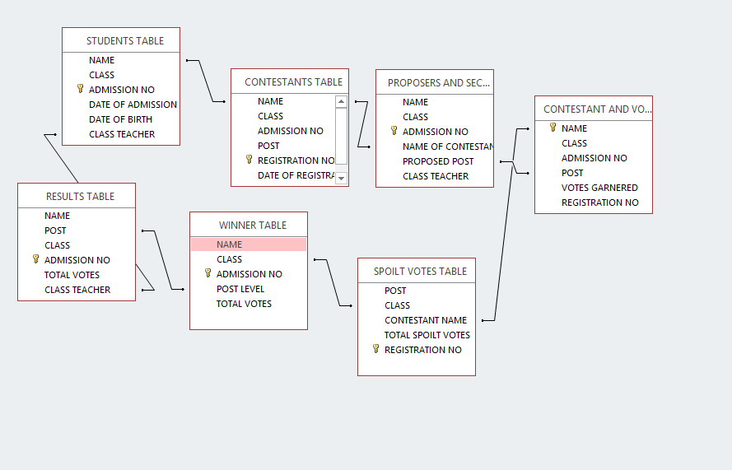

Figure 30

## 4.3: INPUT SCREENS CONSTRUCTION

## DATA ENTRY FORM CONSTRUCTION

Forms are mainly constructed from the underlying tables and they follow the relationship.

Some of forms in Rehema Electoral System are:

* Class and Class Teacher Form
* Contestants and Votes Garnered Form
* Contestant Form
* Proposers and Seconders Form
* Result Form
* Spoilt Votes Form
* Students Form
* Voters Form
* Winners Form

### CLASS AND CLASS TEACHER FORM

This form draws its data form the class and class teacher table. It’s where records for teachers and their respective class are recorded. It has commands such save, add record, delete record, find record, and print command.

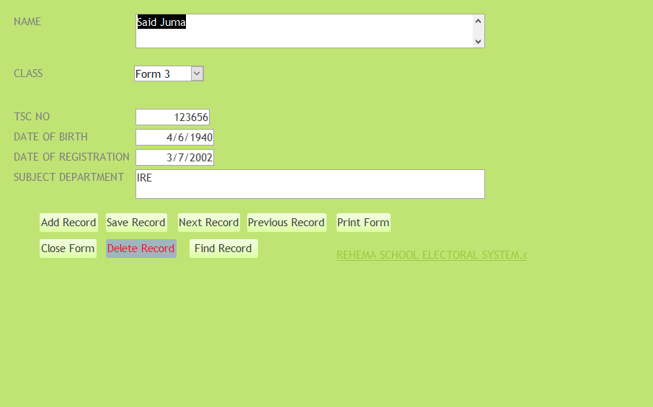

Figure 31

### CONTESTANT AND VOTES GARNERED FORM

This form draws its data form the contestant and votes garnered table. The form is used to input records concerning contestant’s details and votes they garnered. It has commands such as save, delete, add, find record and close form command.

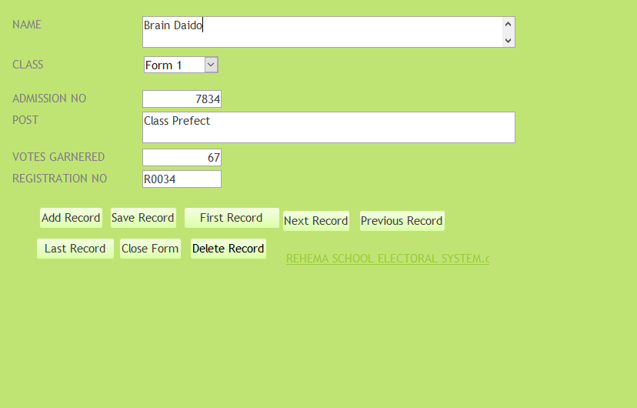

Figure 32

### CONTESTANTS FORM

This form draws its data from the contestants table. It’s a platform to input details concerning those want to vie for particular leadership post in the school. It has commands such as the save, add, delete, find and close form record.

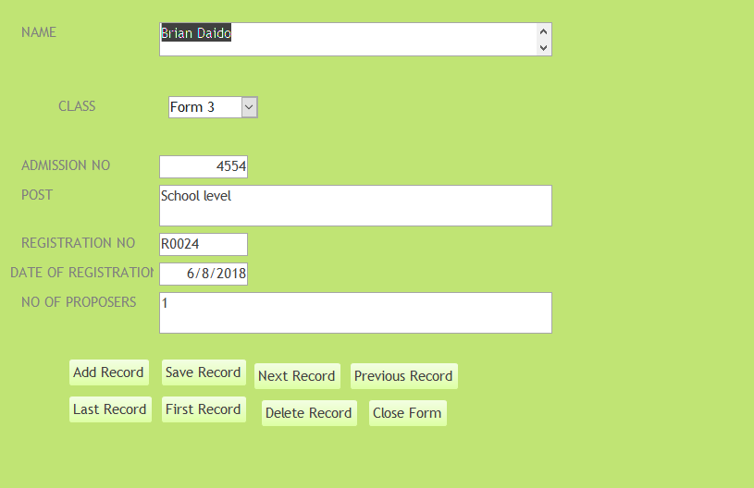

Figure 33

### PROPOSER AND SECONDER FORM

This form draws its data from the proposers and seconders table. It’s a platform to input data concerning students who propose and seconder contestants. It has commands such as save, delete, add, close and find record.

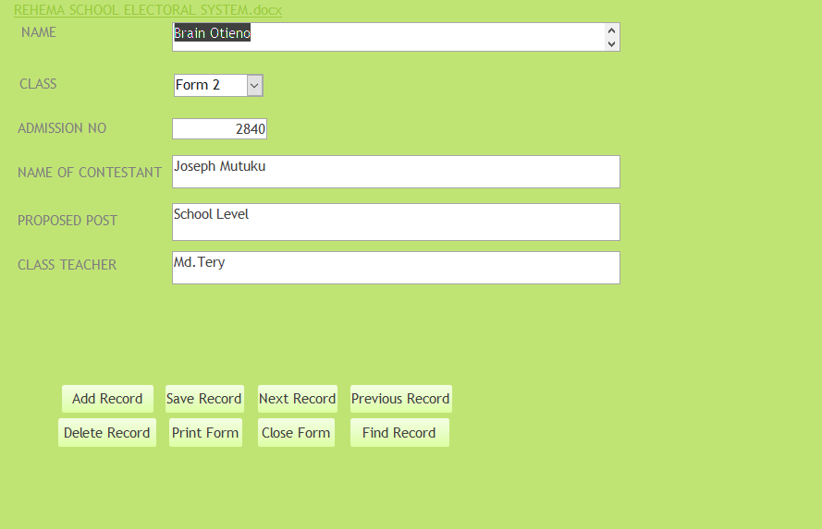

Figure 34

### RESULTS FORM

This form draws its data from the result table. It’s a form for inputting details concerning contestants results such as their total votes and registration number. It has commands such as the add, save, delete, find record and close form.

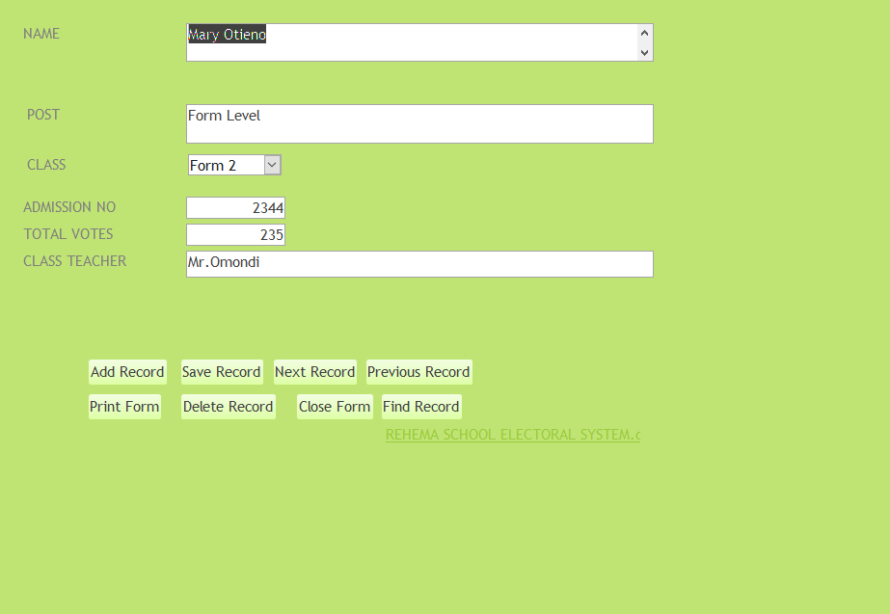

Figure 35

### SPOILT VOTES FORM

This form draws its data from the spoilt votes table. It’s a form for inputting contestants spoilt votes. It has commands such the save, add, delete, find record and close form command.

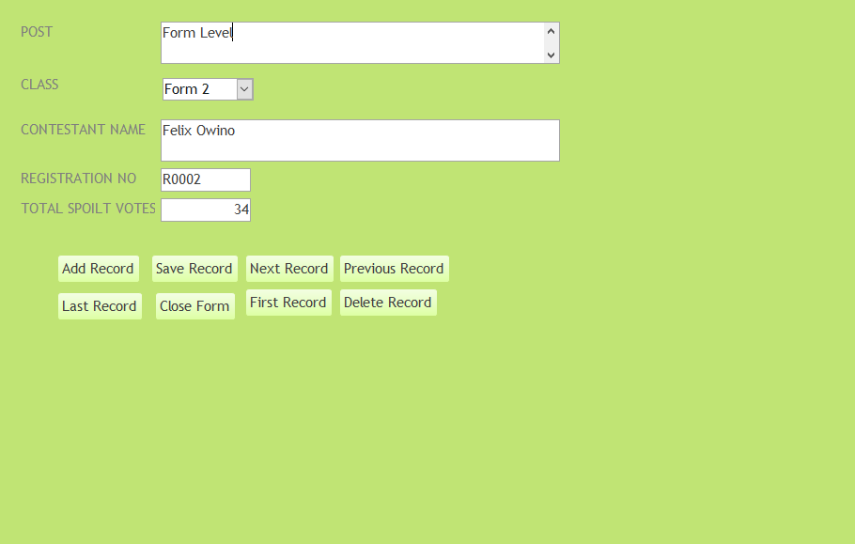

Figure 36

### STUDENTS FORM

The student form draws data form the student table. It’s where students input their personal details which may be used by the administration to know them better. It has commands such the save, delete, add, find record, next record and close form.

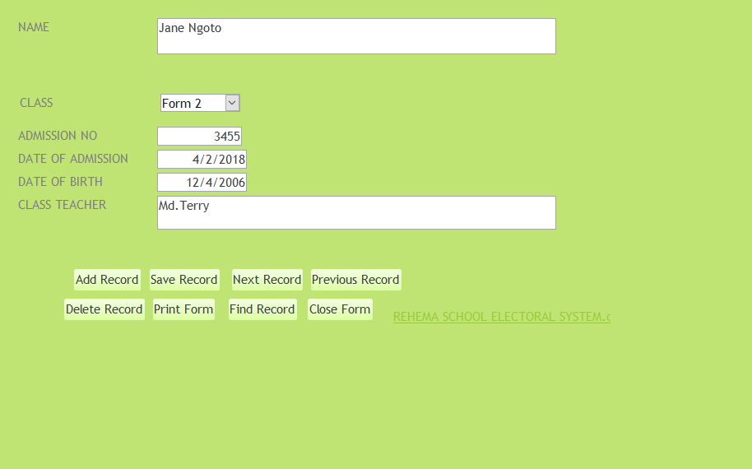

Figure 37

### VOTERS FORM

This form draws its data form the voters table. It’s a platform where voters register themselves for registration. It contains commands such as the save, delete, add, find record, previous record, next record and close form command.

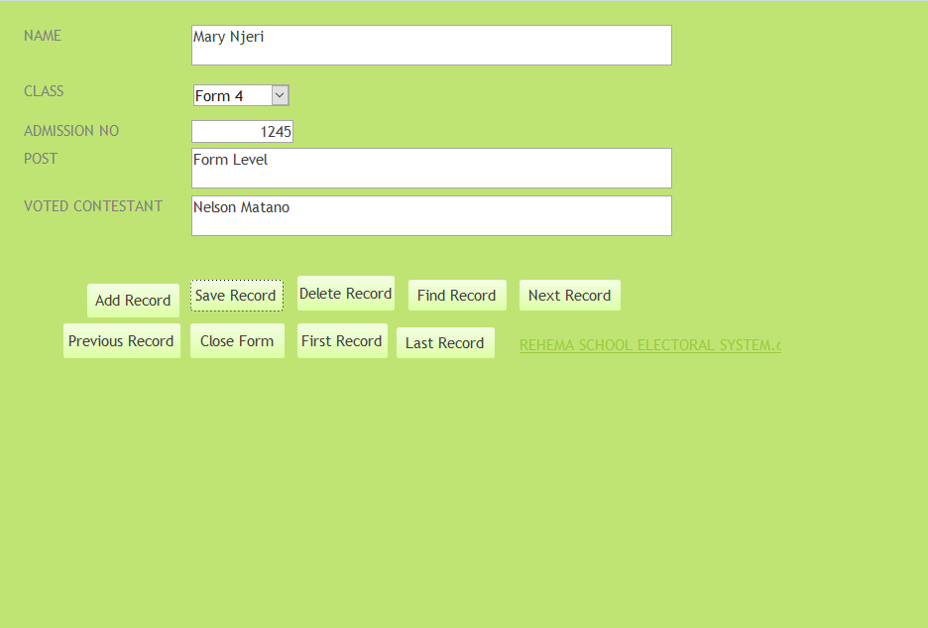

Figure 38

### WINNER FORM

This form draws its data from the winner table. It is a platform for inputting the winners for each post. It has commands such as the next, previous, delete, find record, add record and the close form command.

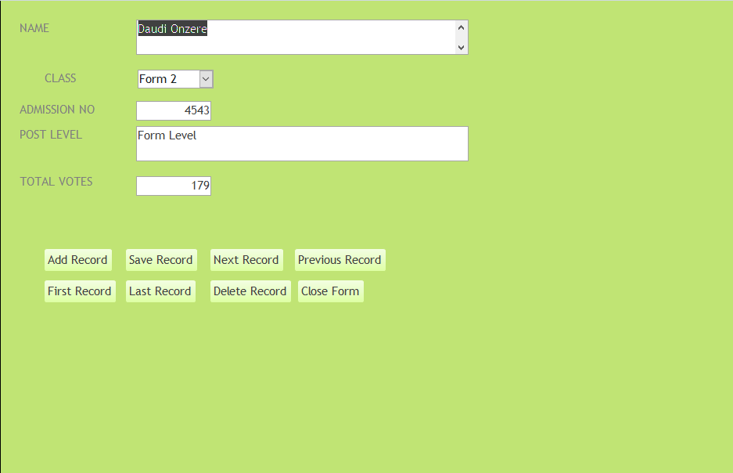

Figure 39

## 4.5: DATA MANIPILATION

### PROPOSERS AND SECONDERS QUERY

This query shows the contestants with adequate proposers and seconders.

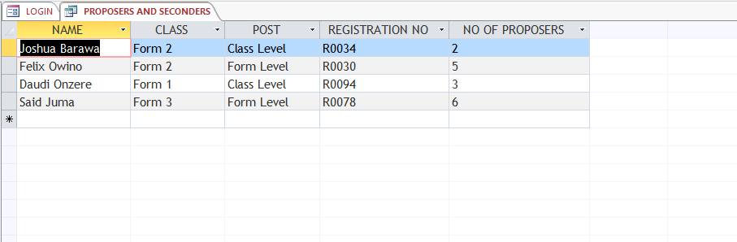

Figure 40

### SCHOOL LEVEL WINNERS QUERY

This query shows students who won the school level post.

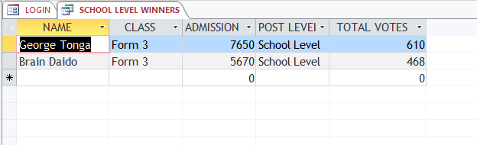

Figure 41

### FORM LEVEL QUERY

This query shows the students who won in the form level post.

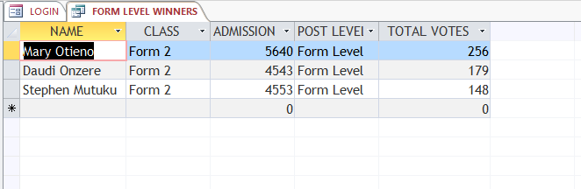

Figure 42

### CLASS LEVEL QUERY

This query shows students who in the class level post.

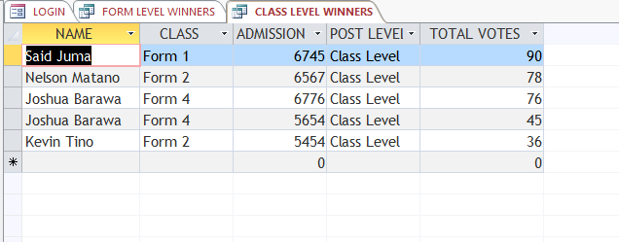

Figure 43

### CONTESTANTS SCHOOL LEVEL QUERY

This query shows contestants vying for school level post.

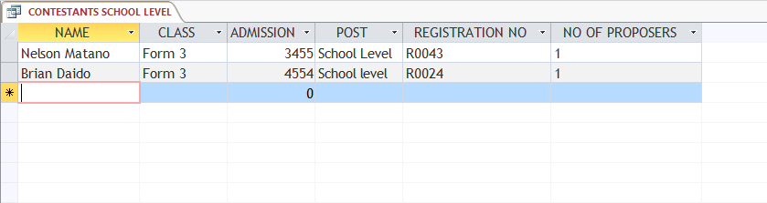

Figure 44

### CONTESTANTS FORM LEVEL QUERY

This query shows contestants vying for form level post.

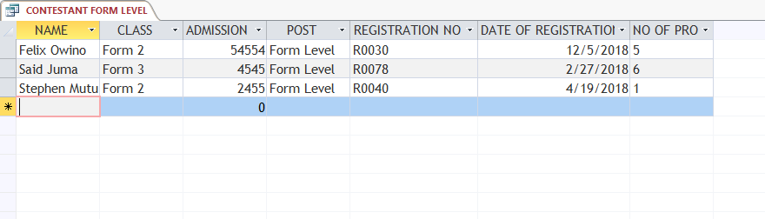

Figure 45

### CONTESTANT CLASS LEVEL QUERY

This query shows contestants vying for class level post

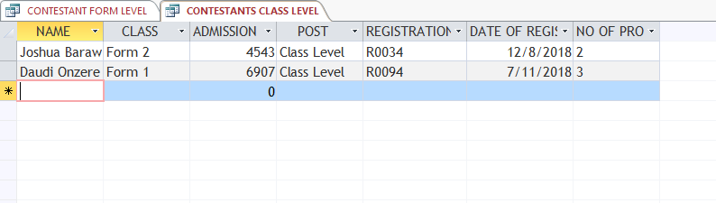

Figure 46

### SCHOOL LEVEL VOTES QUERY

This query computes total votes for each contestant at school level post.

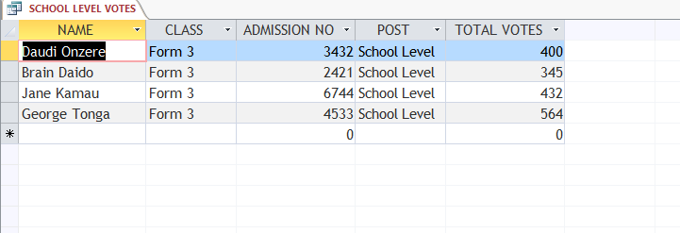

Figure 47

## 4.6: OUTPUT SCREEN CONSTRUCTION

### CONTESTANT AND VOTES GARNERED REPORT

This report gives details about contestants and votes garnered.

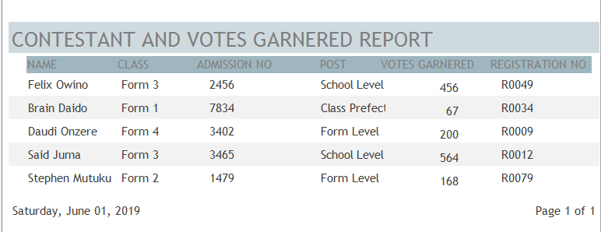

Figure 48

### STUDENTS REPORT

This report show details concerning students.

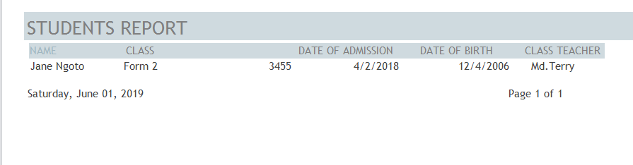

Figure 49

### VOTERS REPORT

This report shows students who participated in voting.

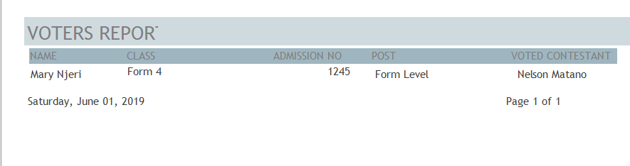

Figure 50

### RESULTS REPORT

This report shows results for the election for every contestant.

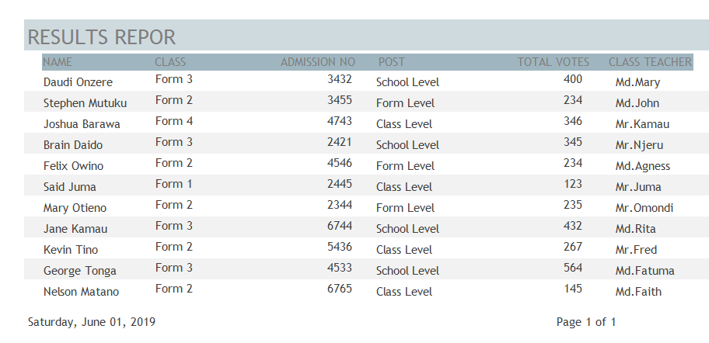

Figure 51

### SCHOOL LEVEL WINNERS REPORT

This report shows the contestants who won in the school level category.

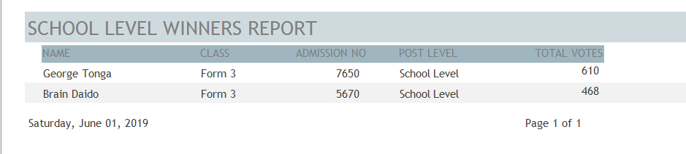

Figure 52

### FORM LEVEL WINNERS REPORT

This report shows the contestants who won in the form level category.

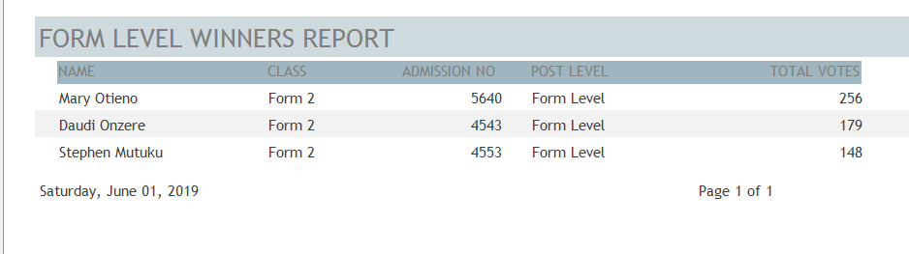

Figure 53

### CLASS LEVEL WINNERS REPORT

This report shows the contestants who won in the class level category.

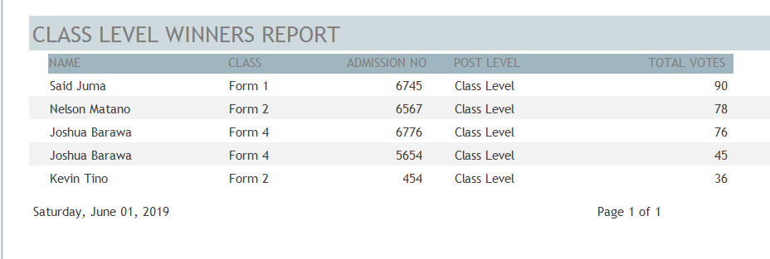

Figure 54

# CHAPTER 5: PROGRAM REQUIREMENTS AND INTALLATION

## 5.1: Requirements

* Operating system windows 7, 8 or 10
* Microsoft access 2013
* 250 GB hard disk
* Keyboard, mouse and printer
* CD Drive

## 5.2: Installation

* Insert the CD containing the program in the CD drive.
* Right click on **REHEMA ELECTEROL SYSTEM** program file icon and click copy.
* Paste the file in the local drive C by right clicking on it and clicking paste.
* Double click on the program file icon in local drive C to open.
* Pin the program into the start menu

## 5.3: Loading the system

1. *Click the start button then double click on the file REHEMA SCHOOL ELECTROL SYSTEM file and it will automatically open.*

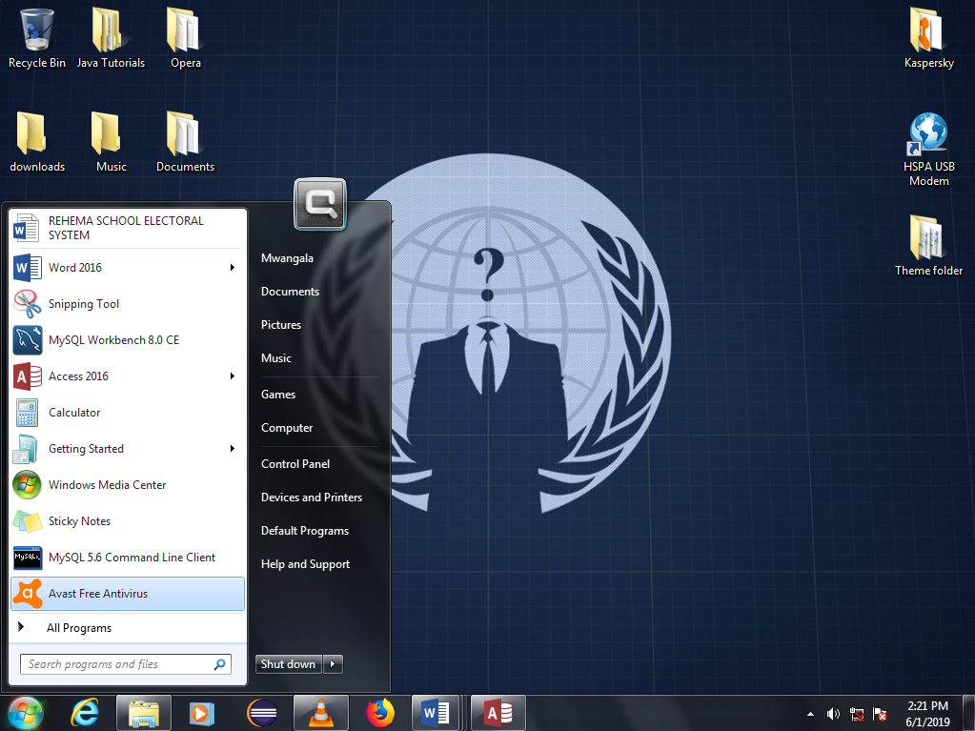

Figure 55

1. *A welcome menu appears where you click the LOGIN button to continue.*

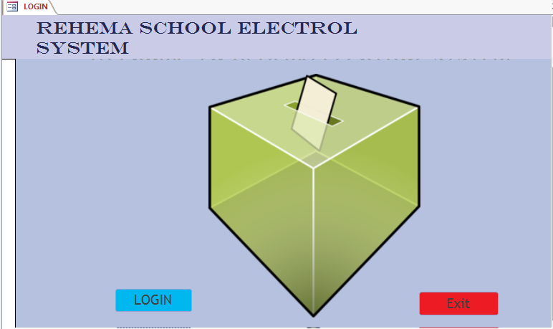

Figure 56

1. *The main menu appears where you can access form and reports.*

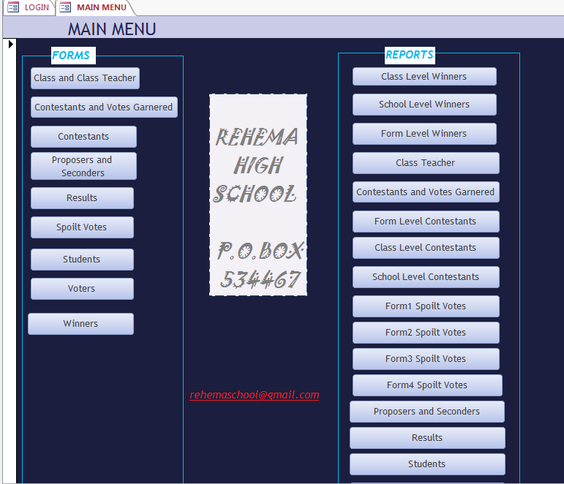

Figure 57

## 5.4: DATA ENTRY AND MANIPULATION

Start by opening the form that you would want to fill from the main menu by pressing the button with the form name and the form will automatically open. Click the add button and an empty form appears for filling.

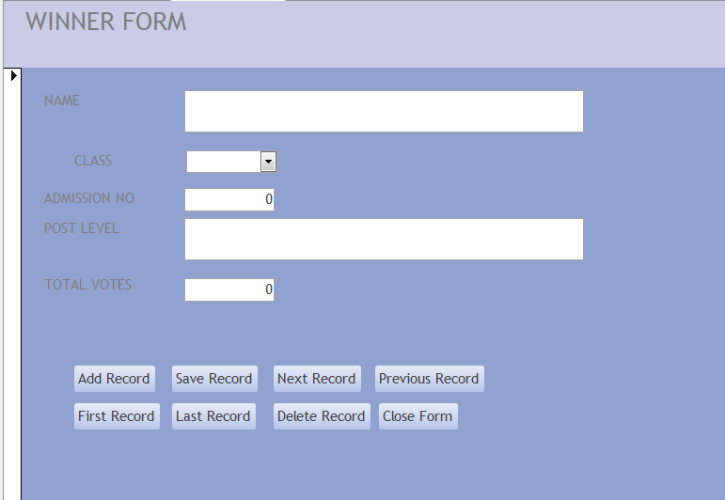

Figure 58

After inputting click the save button to save your records and close the form by clicking the close button.

## 5.5: EXITING THE SYSTEM

*Click the exit button to exit the system.*

## 5.6: ERROR MESSAGES

When entering data most of the users make mistakes which results to errors. Here are some error messages that you may encounter:

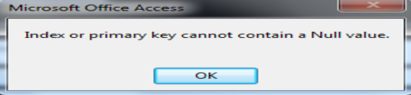

Description: Occurs when you leave the primary field empty in a form.

Figure 59

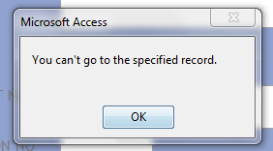

Description: Occurs when a user tries to go to the next or previous record while at the end of the list.

Figure 60

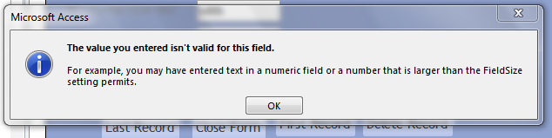

Description: Occurs when you input an invalid value in field.

Figure 61

# CHAPTER 6: CONCLUSION AND RECOMMENDATIONS*.*

## 6.1: CONCLUSION

The system is going to help Rehema school perform their election in appropriate way. It is going to replace the old manual system.

In the new computerized system every election activity will be done using a computer which will increase accuracy and spending cost. This is going to provide a fair and just election.

## 6.2: RECOMMENDATIONS

The system is recommended for use as it has several advantages over the previous manual system as well as eliminating the challenges faced by the old system. The users will be required to be computer literate since the system is computer dependent. The system internal setting should not be altered.

## 6.3: BIBLIOGRAPHY

S. Mburu and G. Chemwa: Longhorn Secondary Computer Studies Book 4

S. Mburu and G. Chemwa: Longhorn Secondary Computer Studies Book 3

S. Mburu and G. Chemwa: Longhorn Secondary Computer Studies Book 2

# PROJECT APPENDIX

## Appendix 1:CLASS AND CLASS TEACHER TABLE

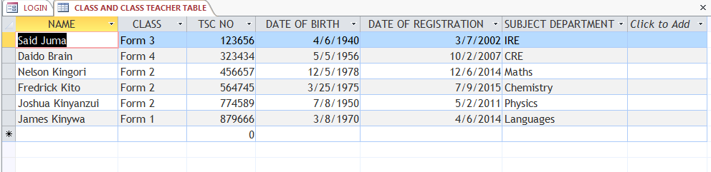

Figure 62

## Appendix 2: CONTESTANTS TABLE

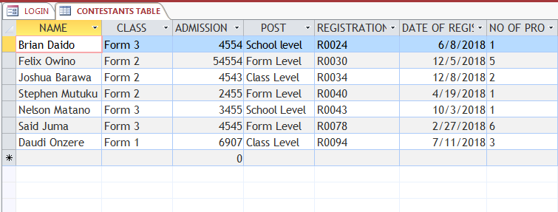

Figure 63

## Appendix 3: RESULTS TABLE

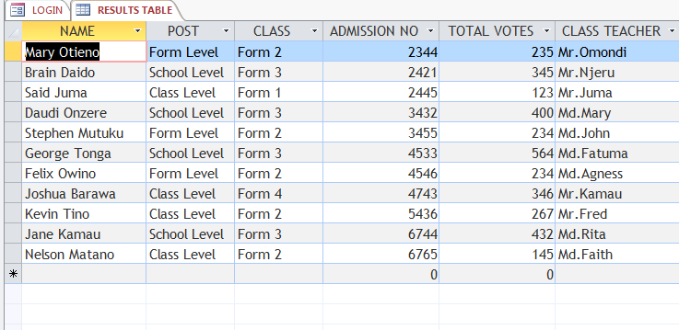

Figure 64

## Appendix 4: SPOILT VOTES TABLE

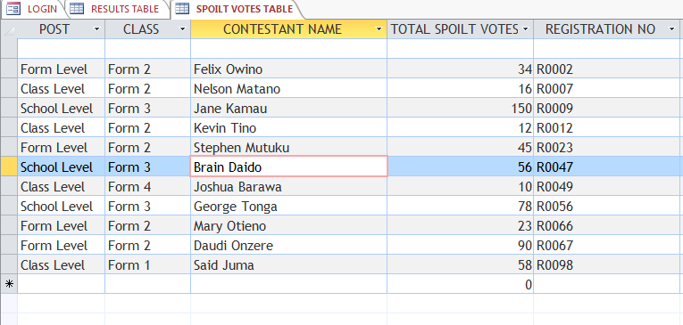

Figure 65

## Appendix 5: WINNER TABLE

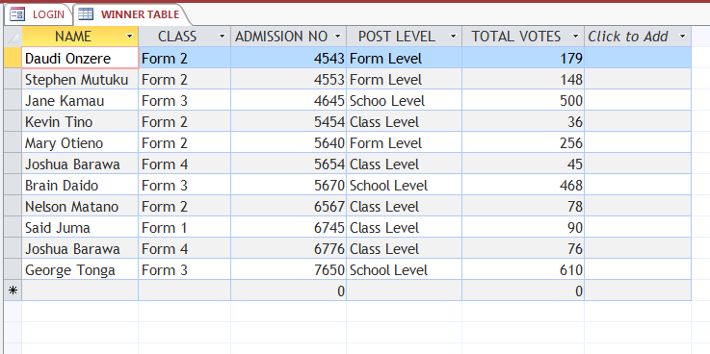

Figure 66

## Appendix 6: CONTESTANTS AND VOTES GARNERED TABLE

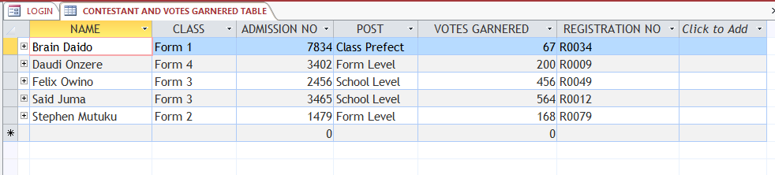

Figure 67